**EDGE Final Project**

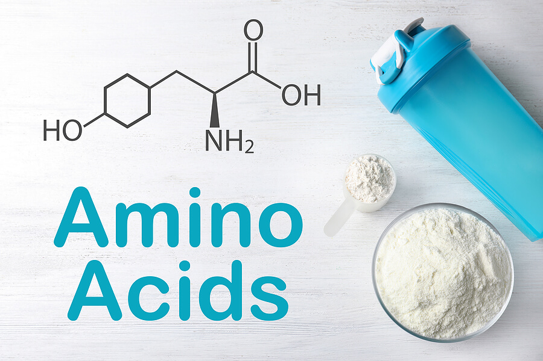

***Topic Name: Synthesis of Amino Acids***

**Submitted by:**

Md. Neamul Hassan

Department of Chemistry

University of Barishal



Contents

1. Introduction 3

2. Biosynthesis of Amino Acids 3

3. Regulation of Amino Acid Synthesis 4

• Feedback Inhibition 4

• Enzyme Induction/Repression: 4

4. Applications of Amino Acid Synthesis 4

Food Industry: 4

Pharmaceutical Industry: 4

Cosmetics Industry: 4

Animal Feed Industry: 4

Research Applications: 4

5. Conclusion 5

References: 5

**Topic Name: Synthesis of Amino Acids**

# 1. Introduction

**amino acid**, any of a group of organic molecules that consist of a basic amino group (―NH2), an acidic carboxyl group (―COOH), and an organic R group (or side chain) that is unique to each amino acid.

The term amino acid is short for α-amino [alpha-amino] carboxylic acid. Each molecule contains a central carbon (C) atom, called the α-carbon, to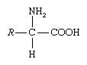 which both an amino and a carboxyl group are attached. The remaining two bonds of the α-carbon atom are generally satisfied by a hydrogen (H) atom and the R group (1).

2. Biosynthesis of Amino Acids(2)

* Amino acids are classically considered as the building blocks from which proteins are synthesised. Besides this, some of them play a major role in the regulation of protein turnover and signal transduction, transport of nitrogen and carbon across the organs, and neurotransmission.
* The biosynthesis of amino acids involves several biochemical pathways in which amino acids are assembled from other precursors. The biosynthesis of amino acids is distinct from that involving lipids or carbohydrates because it includes the use of nitrogen.
* The fixation of nitrogen is a process that converts atmospheric nitrogen to a form that can be used biologically.
* The pathways for the synthesis of essential amino acids are present only in microorganisms and plants.
* Nine of 12 nonessential amino acids are synthesised from amphibolic intermediates, whereas three amino acids (tyrosine, cysteine and hydroxylysine) derive from essential amino acids. Amino acid transaminases, glutamate dehydrogenase and glutamine synthetase play a central role in the synthesis of nonessential amino acids.
* The major pathway by which ammonia is incorporated into amino acids is through the reductive amination of α-ketoglutarate to glutamate. Ammonia is highly toxic for animals. Glutamine is a nontoxic carrier of ammonia.
* In the human adult as much as 200–250 g of proteins are degraded daily, and their constituent amino acids are in large part reutilised in protein synthesis.
* Amino acid deficiency states can result if any of the essential amino acid is present in inadequate amounts or omitted from the diet.
* Alanine, glutamate and glutamine are crucial links between energy and protein metabolism. Moreover, glutamine and alanine biosynthesis in the peripheral tissues (muscle) provides a means for the transport of carbon to the liver for gluconeogenesis and nitrogen for ureagenesis.
* There are several nonprotein functions of amino acids, such as the biosynthesis of purines and pyrimidines, which involve more nonessential than essential amino acids.

# 3. Regulation of Amino Acid Synthesis

Amino acid synthesis is primarily regulated through a mechanism called "feedback inhibition," where the end product of a biosynthetic pathway inhibits the activity of an early enzyme in the pathway, preventing further production of the amino acid when levels become sufficient; this often occurs at the level of gene expression, controlling the production of the enzymes involved in amino acid synthesis (3).

* Feedback Inhibition The most common regulatory mechanism, where the final amino acid in a pathway inhibits the first committed step enzyme (3).
* Enzyme Induction/Repression: Regulation can also occur by altering the activity of enzymes through allosteric modulation or post-translational modifications (3).

4. Applications of Amino Acid Synthesis(4)

## Food Industry:

* **Nutritional enhancement:** Increasing the levels of essential amino acids in crops like corn and soybeans through genetic modification to improve protein quality in food sources.
* **Flavor enhancement:** Using specific amino acids to enhance the taste of food products.

## Pharmaceutical Industry:

* **Drug development:** Synthesizing amino acid-based drugs or precursors for complex drugs, including antibiotics, anti-cancer agents, and neurotransmitters.
* **Peptide synthesis:** Creating peptides with specific functions by linking together different amino acids.

## Cosmetics Industry:

* **Skin conditioning agents:** Utilizing amino acids for their moisturizing and hydrating properties in skincare products.
* **Hair care products:** Amino acids can improve hair texture and strength.

## Animal Feed Industry:

* **Protein supplementation:** Adding essential amino acids to animal feed to optimize protein intake and animal growth.

## Research Applications:

* **Protein structure studies:** Synthesizing modified amino acids to investigate protein folding and function.
* **Metabolic engineering:** Studying and manipulating metabolic pathways to produce specific amino acids in microorganisms.
* **Biocatalysis:** Developing enzymes that utilize amino acids as substrates for various chemical reactions.

# 5. Conclusion

This project has explored the fascinating world of amino acid synthesis, a fundamental process underpinning all life. We have examined the intricate network of biosynthetic pathways, originating from central metabolic intermediates and culminating in the diverse array of amino acids. From the essential role of nitrogen assimilation to the elegant control mechanisms like feedback inhibition, the complexity and efficiency of these pathways are truly remarkable. We have also touched upon the broader significance of amino acids beyond protein synthesis, highlighting their involvement in various physiological processes. Furthermore, the industrial and biotechnological applications of amino acid synthesis, from food production to pharmaceutical development, underscore the practical importance of understanding these pathways. While this report has provided an overview of key aspects, the field of amino acid biosynthesis continues to be an active area of research, with ongoing efforts to elucidate further details and explore novel applications. The ongoing study of these pathways promises to not only deepen our understanding of fundamental biology but also pave the way for advancements in medicine, agriculture, and biotechnology.

# References:

1. **Reddy, Michael K.** amino acid. *Encyclopedia Britannica.* [Online] 02 02, 2025. Encyclopedia Britannica.

2. **Giacomo Deferrari, Irene Mannucci, Giacomo Garibotto.** Amino Acid Biosynthesis. *Wiley Online Library.* [Online] 04 19, 2001. https://onlinelibrary.wiley.com/doi/abs/10.1002/9780470015902.a0000628.pub2.

3. **Sadia Naz, Pi Liu, Umar Farooq & Hongwu Ma.** Insight into de-regulation of amino acid feedback inhibition: a focus on structure analysis method. *Microbial Cell Factories.* [Online] 2023. https://microbialcellfactories.biomedcentral.com/articles/10.1186/s12934-023-02178-z#:~:text=Amino%20acids%20regulate%20their%20biosynthetic,committed%20steps%20of%20a%20pathway..

4. *Application of Amino Acids in the Structural Modification of Natural Products: A Review.* **Xu Q, Deng H, Li X and Quan Z-S.** 2021, Vol. 9.